Objectives:

* To become familiar with using arrays and array lists
* Creating an array table
* To Sum + Average + get the MAX and MIN using arrays
* Using loops with arrays

An array variable can hold multiple values of the SAME type (integer or String) types

Int [] numbers >> the [] brackets make the numbers variable an integer array

Subscripts are the numbers that are assigned in arrays and they always start with 0

See page 407 Figure 7-3

Numbers[0] = 100;

Numbers[1] = 200;

Numbers[3] = 300;

Numbers[4] = 400;

Numbers[5] = 500;

When an array is out of bounds? Means when the array index is greater than the array length

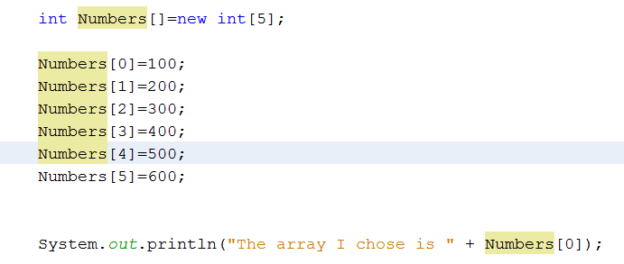

1-D Array List Array

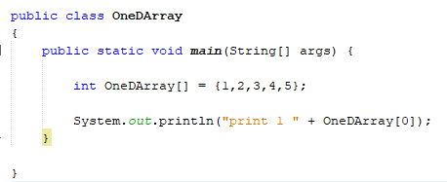

2-D List Array

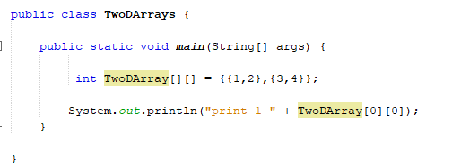

3-D List Array

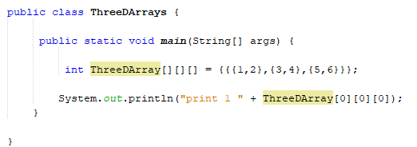

# Adding arrays:

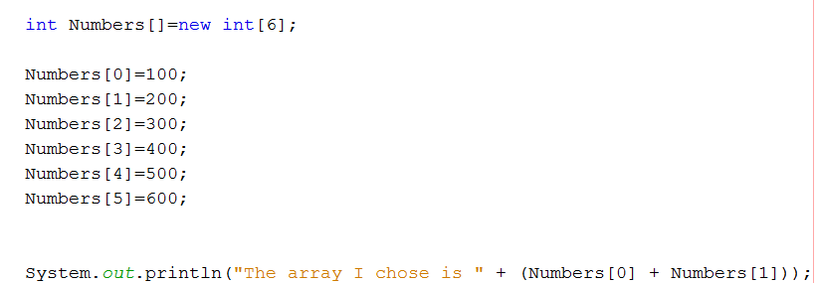

# Using a Loop to retrieve all arrays:

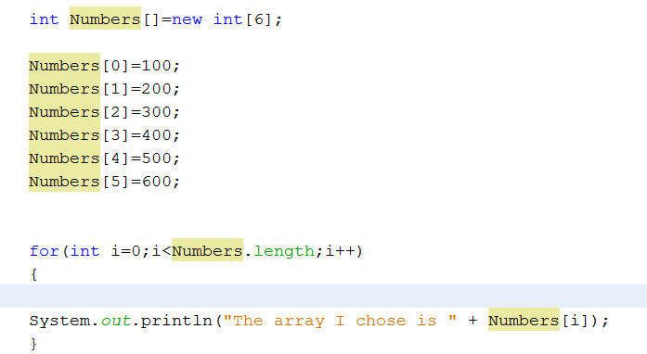

# Getting the sum and average for all arrays:

Add two variables

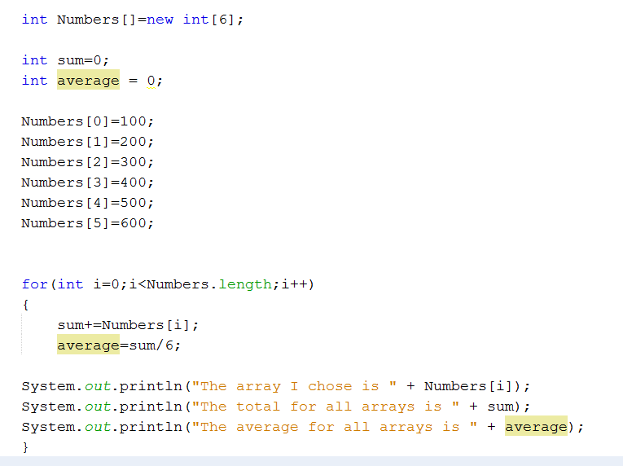

Get the sum and average

# Take out the + from the +=sum

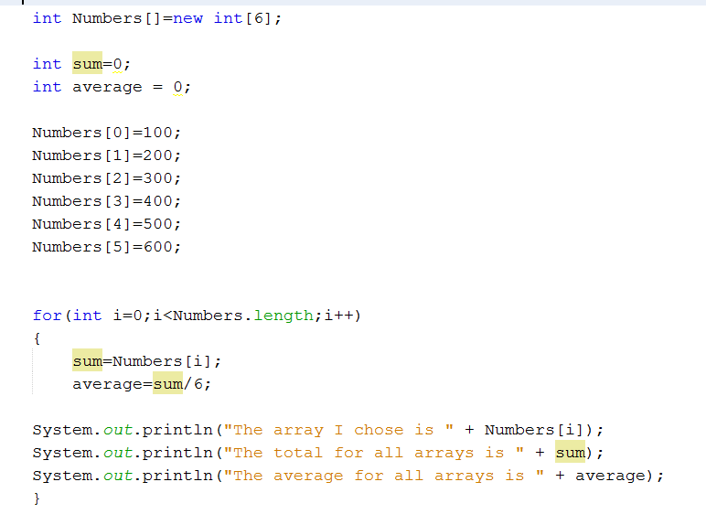

# Create a new class and name it ListArrays:

A list array is an array that lists numbers or characters in a list and the array numbers are NOT visible

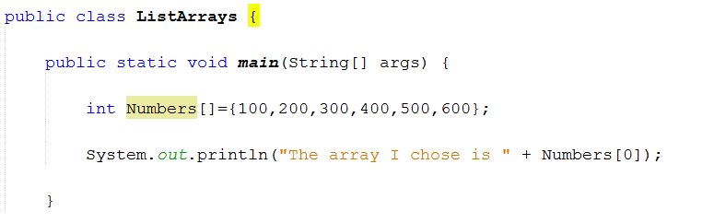

# Where are the numbers?

int Numbers[]={100,200,300,400,500,600};

0 , 1, 2, 3, 4, 5 (Index numbers)

Character List arrays

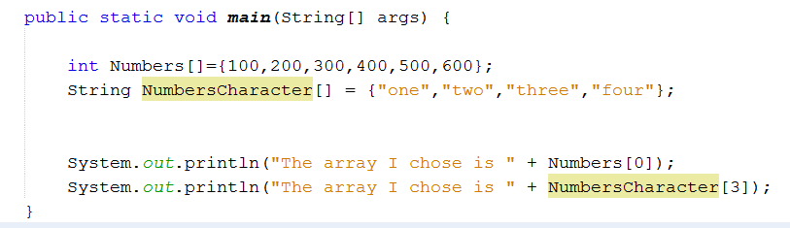

# Try this…

* Create 1 character array with the following names
  + Jane, Bob, Bill, and Howard
* Create 1 integer array with the following ages
  + 21, 22, 23 and 24
* The output will be as shown below

Screen Clipping

# Create a new class and name it InputArrays & Math Class

* Here is an example how we can input into console and get an output from an array using a Math Class

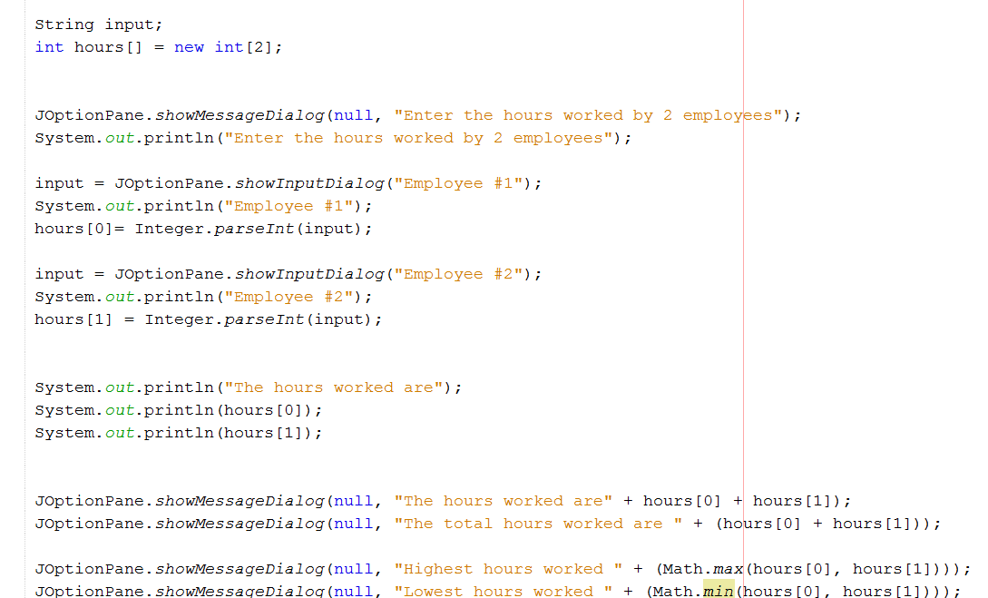

# Using a JOptionPane to input

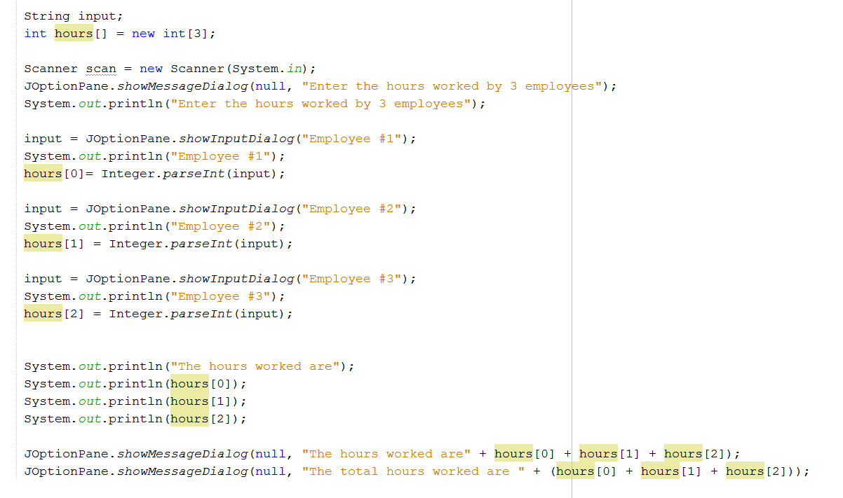

# Create a new class and name it SalesArray

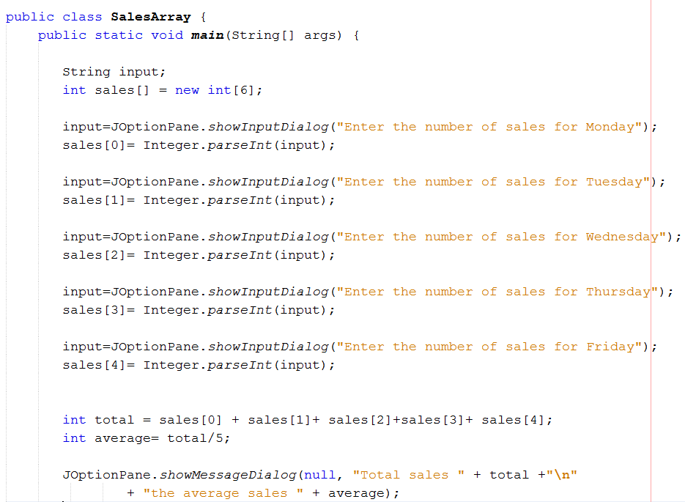

Passing arrays to methods

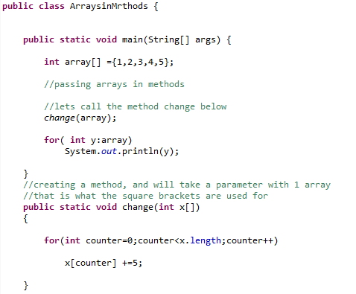

Totaling arrays

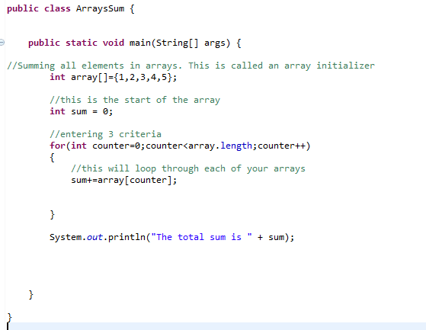

# Creating a multi-dimension array

